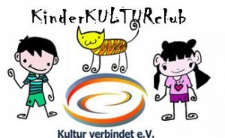 c/o Arzu Cetinkaya
Bernkasteler Straße 21, 53175 Bonn

Bonn, 26. October 2020
Dear parents,

the club „Kultur verbindet e.V.“ would like to invite: ___________________________

When: | Sunday, 15th November 2020, 11:00 – 13:00
Where: | Meetingpoint (requested): Jugendzentrum K7, Mallwitzstraße 9 – 11, Pennenfeld (Bus 856 oder 612 from Löbestraße to Ellesdorfer Straße, then 400 m footway or from Bahnhof Mehlem 900 m by foot)
What: | We build electric cars.  Even a small battery has enormous energy. It can move small ventilators, turn a chain of lights on or move small electric cars.  You are going to build the car on your own. The car will be created with wood, paperboard, wheels and electric parts. You are also going to decorate your supercar with colorful paper, sponge rubber, eyes and other nice stuffs. Of course we will have a car race finally!  For kids between 6 – 11 years old. Please bring a mouth and nose protection with you.
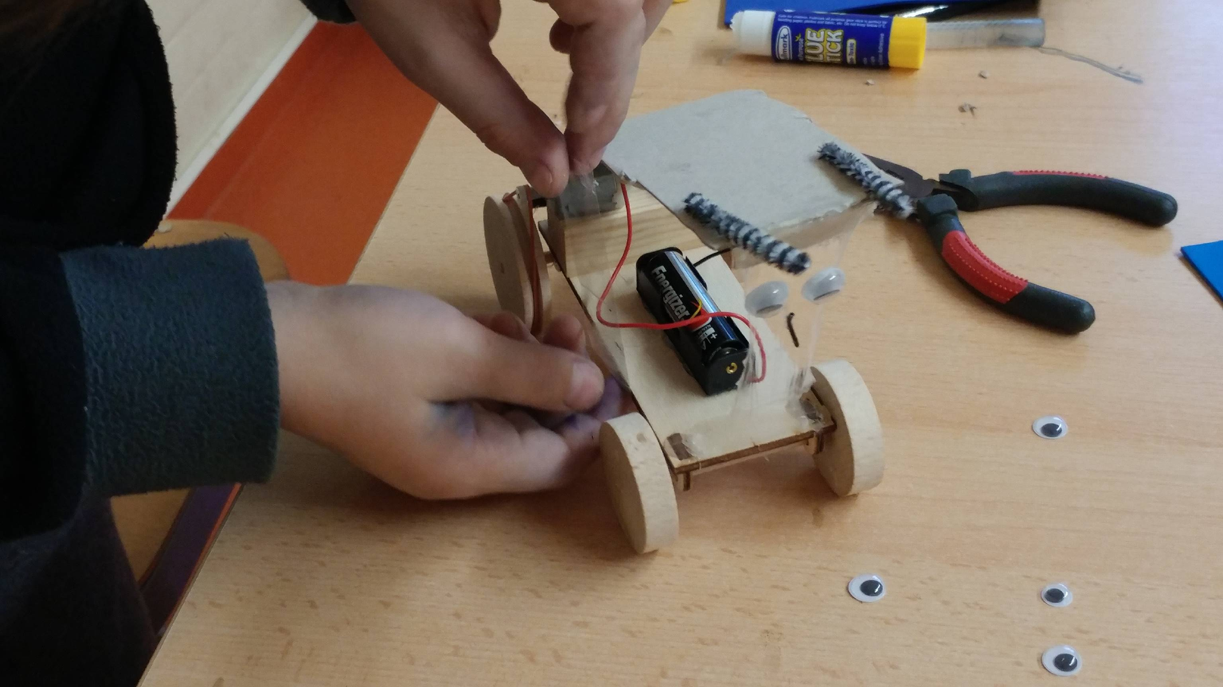
Fotos: privat
Registration:
Shiri Dettmann-Nouri Tel: 0228-372 80 86 or 0151-111 925 47.
Email to tsgumei@yahoo.de.
or contact me:
……………………………………… Tel.:...............................................................
Email:…………………………………………………………

(Dear godparents: please write here your name / telephone number or email if you want to registrate a child for its parents. If the parents are agreed with the attendance of their child then contact Mrs. Dettmann-Nouri).

All valid registration will be confirmed by email or by phone.
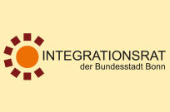
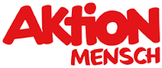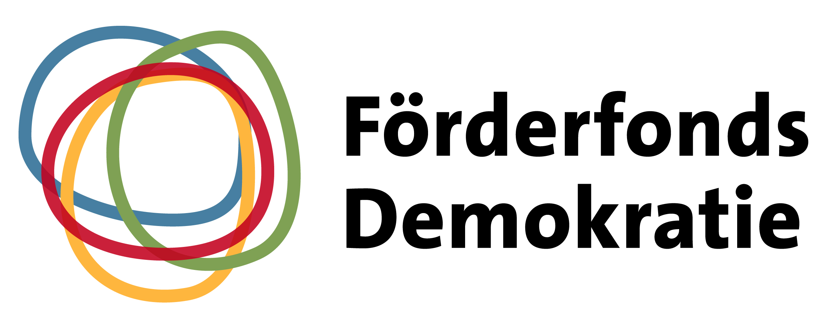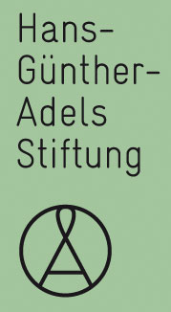
gefördert durch:

Gefördert durch:

